EX NO:6 | E-TICKETING

AIM:
To draw the diagrams[class] for the E-ticketing system.
SOFTWARE USED:
Umbrello
CLASS DIAGRAM:

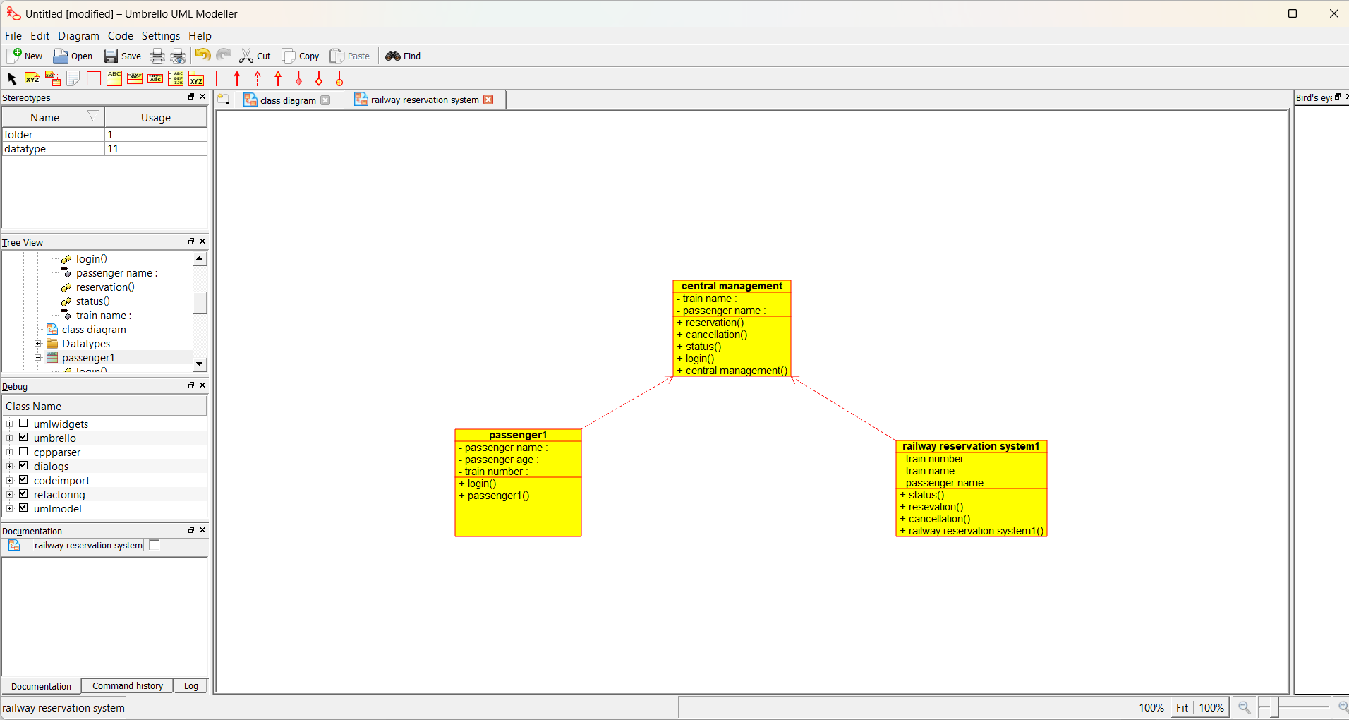

RESULT:
Thus the diagrams[class] for the E-ticketing system has been designed, executed and output is verified.

EX NO:07 | CREDIT CARD PROCESSING SYSTEM

AIM:
To draw the diagrams [class] for Credit Card Processing .
SOFTWARE USED:
Umbrello
CLASS DIAGRAM:

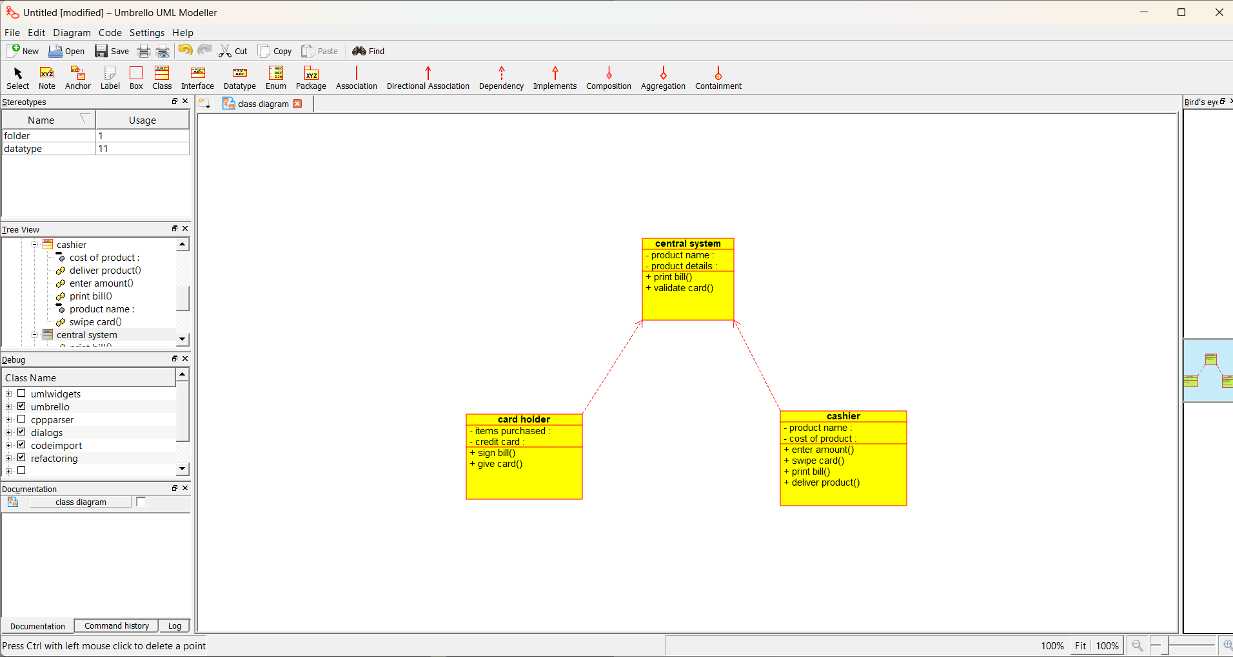

RESULT:
Thus the diagrams[class] for the credit card processing system has been designed, executed and output is verified.

EX:NO:08 | SOFTWARE PERSONNEL MANAGEMENT SYSTEM

AIM:
To draw the diagrams [class] for software personnel management system.
SOFTWARE USED:
Umbrello
CLASS DIAGRAM:

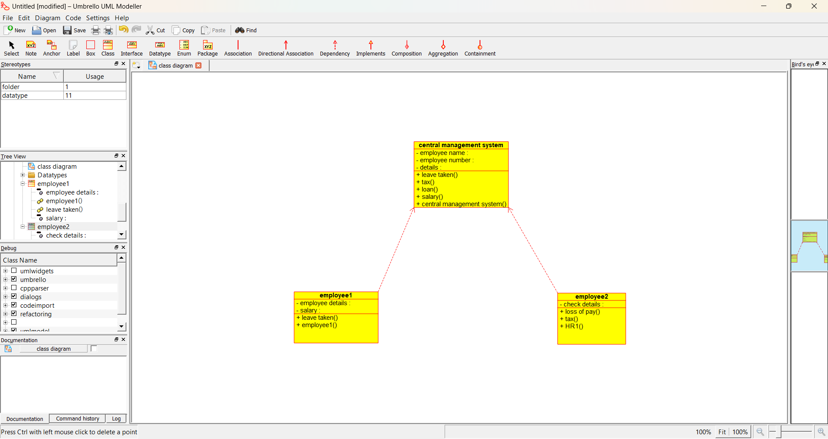

RESULT:
Thus the diagram [class] for the Software Personnel Management System has been designed, executed and output is verified.

EX.NO:09 | E-BOOK MANAGEMENT SYSTEM

AIM:
To draw the diagrams [class] for E-book management system.
SOFTWARE USED:
Umbrello
CLASS DIAGRAM:

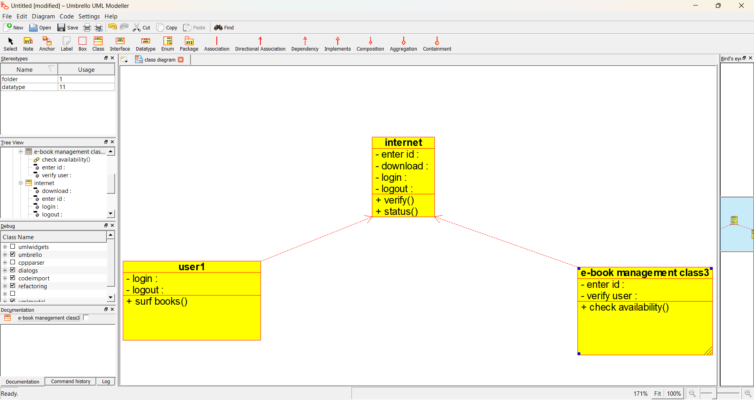

RESULT:
Thus the draw the diagrams [class] for E-book management system.

EX:NO:10 | RECRUITMENT SYSTEM

AIM:
To draw the diagram[class] for recruitment system.
SOFTWARE USED:
Umbrello
CLASS DIAGRAM:

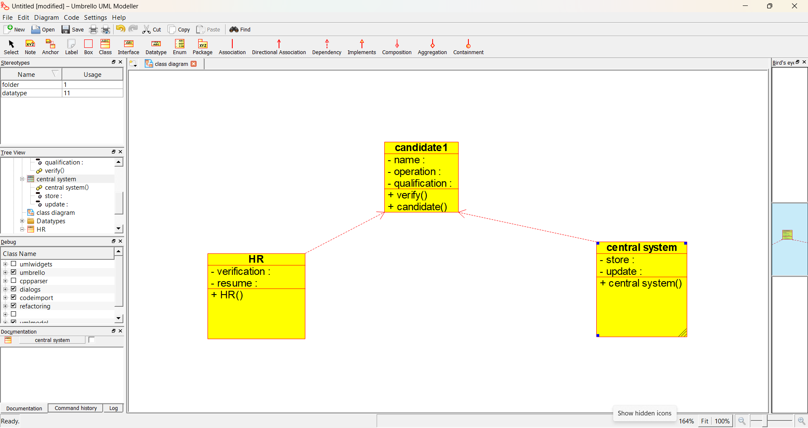

RESULT:
To draw the diagram [class] for recruitment system has been designed and output is verified.

